CV Project 4 Connected Components Java

Jonathan Mathew

Project Due 03/19/23

Algorithm Steps

step 0: inFile-->open the input file from argv [1]

Connectness-->argv [2] option-->argv [3] RFprettyPrintFile, labelFile, propertyFile, deBugFile-->open from argv []

numRows, numCols, minVal, maxVal-->read from inFile zeroFramedAry-->dynamically allocate. newLabel --> 0

step 1: zero2D (zeroFramedAry) step 2: loadImage (inFile, zeroFramedAry)

step 3: if option == ‘y’ or ‘Y’

conversion (zeroFramedAry)

step 4: if connectness == 4

connected4 (zeroFramedAry, newLabel, EQAry, RFprettyPrintFile, deBugFile)

step 5: if connectness == 8

connected4 (zeroFramedAry, newLabel, EQAry, RFprettyPrintFile, deBugFile)

step 6: labelFile-->output numRows, numCols, newMin, newMax to labelFile

step 7: printImg (zeroFramedAry, labelFile) // Output the result of pass3 inside of zeroFramedAry

step 8: printCCproperty (propertyFile) // print cc properties to propertyFile step 9: drawBoxes (zeroFramedAry, CCproperty, trueNumCC) // draw on zeroFramed image. step 10: imgReformat (zeroFramedAry, RFprettyPrintFile)

step 11: print trueNumCC to RFprettyPrintFile with proper caption

step 12: close all files

CONN 8 Data 1.txt

PrettyPrint.txt

Label.txt

Property.txt

Debug.txt

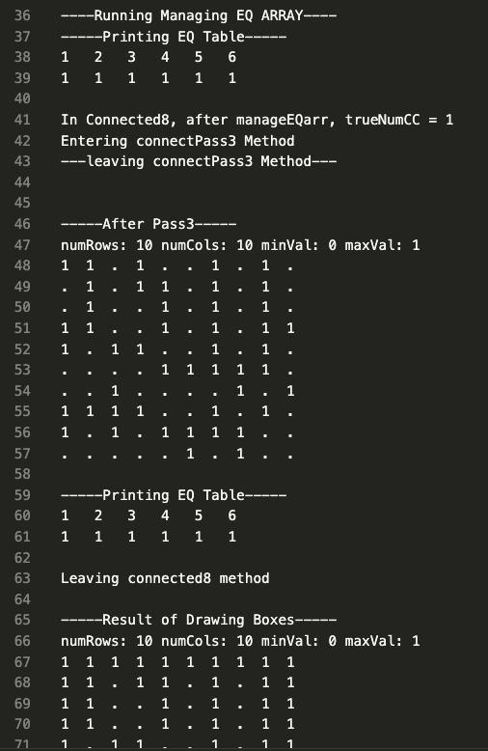

CONN 4 Data 1.txt

PrettyPrint.txt

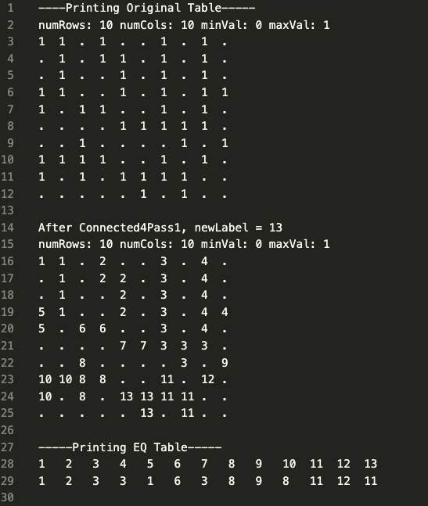

Label.txt

Properties.txt

Debug.txt

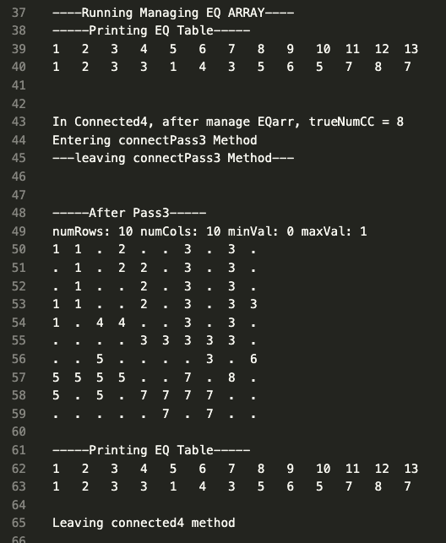

CONN 8 Data 2.txt

PrettyPrint.txt

Label.txt

Propert.txt

debug.txt

CONN 4 Data2.txt CONVERSION

PrettyPrint.txt

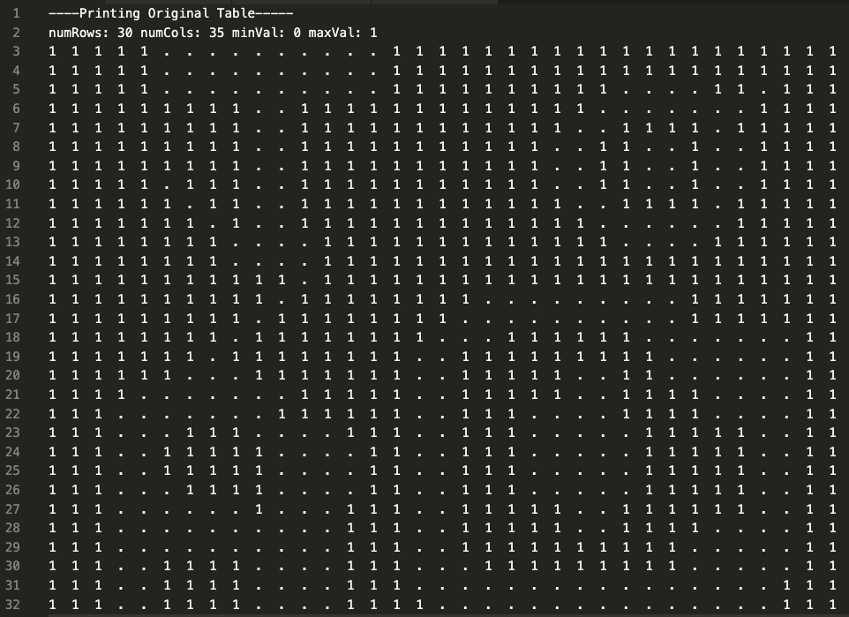

Label.txt

Property.txt

Debug.txt

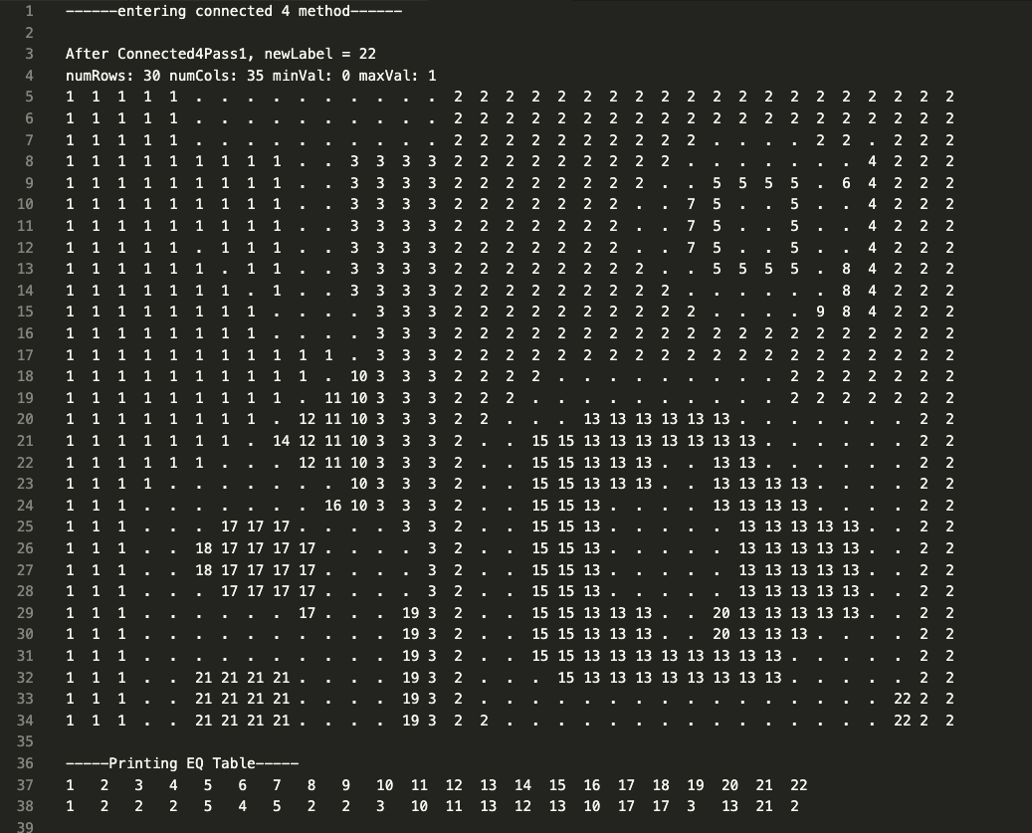

Main.cpp

#include <iostream>

#include <fstream>

#include <sstream>

#include <vector>

#include <cstring>

#include <algorithm>

using *namespace* std;

*struct* Property {

*int* label;

*int* numPixels;

*int* minR;

*int* minC;

*int* maxR;

*int* maxC;

Property() {

label = 0;

numPixels = 0;

minR = 0;

minC = 0;

maxR = 0;

maxC = 0;

}

Property(*int* *label*, *int* *numPixels*, *int* *minR*, *int* *minC*, *int* *maxR*, *int* *maxC*) {

this->label = *label*;

this->numPixels = *numPixels*;

this->minR = *minR*;

this->minC = *minC*;

this->maxR = *maxR*;

this->maxC = *maxC*;

}

};

*class* ccLabel {

*public:*

*int* numRows;

*int* numCols;

*int* minVal;

*int* maxVal;

*int* newLabel;

*int* trueNumCC;

*int* newMin;

*int* newMax;

*int*\*\* zeroFramedAry;

*int* NonZeroNeighborAry[5];

*int*\* EQAry;

*char* option;

Property* CCproperty;

ccLabel(*int* *rows*, *int* *cols*, *int* *min*, *int* *max*, *char* *conver*) {

numRows = *rows*;

numCols = *cols*;

minVal = *min*;

maxVal = *max*;

newLabel = 0;

newMin = 0;

newMax = 0;

option = *conver*;

zeroFramedAry = new *int*\* [numRows + 2];

for (*int* i = 0; i < numRows + 2; i++) {

zeroFramedAry[i] = new *int*[numCols + 2];

for (*int* j = 0; j < numCols + 2; j++) {

zeroFramedAry[i][j] = 0;

}

}

EQAry = new *int*[(*int*)(numRows * numCols) / 4];

for (*int* i = 0; i < (numRows * numCols) / 4; i++) {

EQAry[i] = i;

// cout<<EQAry[i];

}

//Not Sure what to do here come back to it silly goose

}

*void* zero2D(*int*\*\* *arr*, *int* *r*, *int* *c*){

for (*int* i = 0; i < *r*; i++) {

for (*int* j = 0; j < *c*; j++) {

*arr*[i][j] = 0;

}

}

}

*void* negative1D(*int* \**arr*, *int* *size*){

for(*int* i = 0; i < *size*; i++){

*arr*[i] = -1;

}

}

*void* loadImage(ifstream \**infile*, ofstream \**outfile*){

string line;

*int* val;

*int* r=0;

while (getline(\**infile*, line)){

*int* c=1;

istringstream set(line);

while (set >> val){

// cout << val << " ";

zeroFramedAry[r][c] = val;

c++;

}

// cout << endl;

r++;

// // cout <<endl;

}

}

*void* connectPass3(ofstream \**out*){

\**out* << "Entering connectPass3 Method"<<endl;

//step1

for (*int* i = 1; i <= trueNumCC; i++)

{

CCproperty[i].label = i;

CCproperty[i].numPixels = 0;

CCproperty[i].minR = numRows;

CCproperty[i].maxR = 0;

CCproperty[i].minC = numCols;

CCproperty[i].maxC = 0;

}

*int* r=1;

//step 4

while(r<numRows+1){

*int* c=1;

while (c<numCols+1){

*int* pix = zeroFramedAry[r][c];

//step 3

if(pix > 0){

zeroFramedAry[r][c] = EQAry[pix];

*int* k = zeroFramedAry[r][c];

CCproperty[k].numPixels++;

if(r<CCproperty[k].minR)

CCproperty[k].minR = r;

if(r>CCproperty[k].maxR)

CCproperty[k].maxR = r;

if(c<CCproperty[k].minC)

CCproperty[k].minC = c;

if(c>CCproperty[k].maxC)

CCproperty[k].maxC = c;

}

c++;

}

r++;

}

\**out* << "---leaving connectPass3 Method---"<<endl<<endl;

}

*void* conversion(){

for (*int* i = 1; i < numRows+1; i++){

for (*int* j = 1; j < numCols+1; j++){

zeroFramedAry[i][j] = (zeroFramedAry[i][j]+1)%2;

}

}

}

*void* printProperty(ofstream \**property*){

//Image heade

\**property*<<numRows<<" "<<numCols<<" "<<minVal<<" "<<maxVal<<endl;

//number of CCs

// *property<<"trueNumCC: ";

\**property*<<trueNumCC<<endl;

for (*int* i = 1; i <= trueNumCC; i++){

// *property<<"Label: ";

\**property*<<CCproperty[i].label<<endl;

// *property<<"numPix: ";

\**property*<<CCproperty[i].numPixels<<endl;

// *property<<"minRow and MinCol ";

\**property*<<CCproperty[i].minR-1<<" "<<CCproperty[i].minC-1<<endl;

// *property<<"maxRow and maxCol ";

\**property*<<CCproperty[i].maxR-1<<" "<<CCproperty[i].maxC-1<<endl;

}

}

*void* imgReformat(ofstream \**output*){

\**output* << "numRows: " << numRows << " numCols: " << numCols << " minVal: " << minVal << " maxVal: " << maxVal<<endl;

*int* r =1;

//step 12

//step 4

while (r<numRows+1){

//step 10

*int* c =1;

while (c<numCols+1){

//step 5

if(zeroFramedAry[r][c]==0)

\**output*<< ".";

else{

\**output*<< zeroFramedAry[r][c];

}

//step 8

if(zeroFramedAry[r][c] < 10){

\**output* << " ";

}

else{

\**output* << " ";

}

//step 9

c++;

}

\**output* << endl;

//step 11

r++;

}

}

*void* printArr(ofstream \**out*){

\**out*<<"____PRINTING ZERO FRAMED ARR____"<<endl;

for (*int* i = 0; i < numRows+2; i++){

for (*int* j = 0; j < numCols+2; j++){

\**out*<<zeroFramedAry[i][j]<< " ";

}

\**out*<<endl;

}

\**out*<<endl<<endl<<endl;

}

*void* drawBoxes(){

//step 1

*int* index = 1;

// cout<<"trueNumCC is " << trueNumCC<<endl;

while (index <=trueNumCC){

// cout<<"index is " << index<<endl;

//step 2

*int* minRow = CCproperty[index].minR,

minCol = CCproperty[index].minC,

maxRow = CCproperty[index].maxR,

maxCol = CCproperty[index].maxC,

label = CCproperty[index].label;

// cout<<"\tCCproperty["<<index<<"].minR+1: "<< CCproperty[index].minR <<endl;

// cout<<"\tCCproperty["<<index<<"].minC+1: "<< CCproperty[index].minC <<endl;

// cout<<"\tCCproperty["<<index<<"].maxR+1: "<< CCproperty[index].maxR <<endl;

// cout<<"\tCCproperty["<<index<<"].maxC+1 "<< CCproperty[index].maxC <<endl;

// cout<<"\tCCproperty[numPixels] "<< CCproperty[index].numPixels <<endl;

// cout<<"\tCCproperty["<<index<<"].label "<< CCproperty[index].label<<endl;

//step 3

for (*int* r= minRow; r < maxRow+1; r++){

zeroFramedAry[r][minCol] = label;

zeroFramedAry[r][maxCol] = label;

}

for (*int* c = minCol; c < maxCol+1; c++){

zeroFramedAry[minRow][c] = label;

zeroFramedAry[maxRow][c] = label;

}

//step 4

index++;

}

}

*void* printImg(ofstream \**out*){

\**out*<<"-----Printing image-----"<<endl;

\**out*<<numRows<<" " << numCols <<" " << minVal <<" " << maxVal<<endl;

for(*int* i = 1; i < numRows+1; i++){

for (*int* j = 1; j < numCols+1; j++){

if(zeroFramedAry[i][j]==0)

\**out* << ".";

else

\**out* << zeroFramedAry[i][j];

if(zeroFramedAry[i][j] < 10){

\**out* << " ";

}

else{

\**out* << " ";

}

}

\**out*<<endl;

}

\**out*<<endl<<endl<<endl;

}

*void* printEQarr(ofstream \**out*){

\**out*<<endl<<"-----Printing EQ Table-----"<<endl;

for (*int* i = 1; i <= newLabel; i++){

if(i<10)

\**out*<< i << " ";

else

\**out*<< i << " ";

}

\**out*<<endl;

for (*int* i = 1; i <= newLabel; i++){

if(EQAry[i]<10)

\**out*<<EQAry[i] << " ";

else

\**out*<<EQAry[i] << " ";

}

\**out*<<endl<<endl;

}

*void* printEQAll(){

cout<<endl<<"-----Printing EQ all Table-----"<<endl;

for (*int* i = 0; i < (*int*)(numRows * numCols) / 4; i++){

if(i<10)

cout<< i << " ";

else

cout<< i << " ";

}

cout<<endl;

for (*int* i = 0; i < (*int*)(numRows * numCols) / 4; i++){

if(EQAry[i]<10)

cout<<EQAry[i] << " ";

else

cout<<EQAry[i] << " ";

}

cout<<endl<<endl;

}

*bool* case2(*int* *a*, *int* *b*, *int* *cl*, *int* *d*, *int* *r*, *int* *c*){

// if(r==5 && c==4){

// cout<<"\ta:" << a<<endl;

// cout<<"\tb:" << b<<endl;

// cout<<"\tc:" << cl<<endl;

// cout<<"\td:" << d<<endl;

// cout<<endl<<endl<<endl;

// }

*int* arr[] = {*a*,*cl*,*b*,*d*};

*int* last_non_0 = 0,

zeroCount = 0,

sum =0;

for (*int* i = 0; i < 4; i++){

if(arr[i]!=0){

last_non_0 = arr[i];

}

if(arr[i]==0){

zeroCount++;

}

sum+=arr[i];

}

// cout<<a<<b<<cl<<d<<sum<<sum/(4-zeroCount)<<last_non_0<<endl;

// cout<< (sum/(4-zeroCount)==last_non_0)<<"Reee"<<endl;

// if(r==5 && c==4){

// cout<<"sum is: " << sum<<endl;

// cout<<"zeroCOunt is: " << zeroCount<<endl;

// cout<<"last nonzero is: " << last_non_0<<endl;

// cout<<"4-zeroCount:" << 4-zeroCount<<endl;

// cout<<"sum/4-zeroCount:" << sum/(4-zeroCount)<<endl;

// cout<<"\ta:" << a<<endl;

// cout<<"\tb:" << b <<endl;

// cout<<"\tc:" << cl<<endl;

// cout<<"\td:" << d<<endl;

// }

return (*double*) sum/(4-zeroCount)==last_non_0;

// return false;

}

*int* case3(*int* *a*, *int* *b*, *int* *cl*, *int* *d*){

*int* arr[] = {*a*,*b*,*cl*,*d*};

*int* min = 99999;

for (*int* i = 0; i < 4; i++)

{

if(arr[i]<min && arr[i]!=0){

min = arr[i];

}

}

// cout<<"min is: " << min<<endl;

// cout<<"\ta:" << a<<endl;

// cout<<"\tb:" << b<<endl;

// cout<<"\tc:" << cl<<endl;

// cout<<"\td:" << d<<endl;

return min;

}

*bool* case2Pass2(*int* *e*,*int* *f*,*int* *g*,*int* *h*,*int* *pix*,*int* *r*,*int* *c*){

*int* arr[] = {*e*,*f*,*g*,*h*,*pix*};

*int* last_non_0 = 0,

zeroCount = 0,

sum =0;

for (*int* i = 0; i < 4; i++){

if(arr[i]!=0){

last_non_0 = arr[i];

}

if(arr[i]==0){

zeroCount++;

}

sum+=arr[i];

}

return (*double*) sum/(5-zeroCount)==last_non_0;

}

*int* case3Pass2(*int* *e*,*int* *f*,*int* *g*,*int* *h*,*int* *pix*,*int* *r*,*int* *c*){

*int* arr[] = {*e*,*f*,*g*,*h*,*pix*};

*int* min = 99999;

for (*int* i = 0; i < 4; i++)

{

if(arr[i]<min && arr[i]!=0){

min = arr[i];

}

}

// cout<<"min is: " << min<<endl;

// cout<<"\ta:" << a<<endl;

// cout<<"\tb:" << b<<endl;

// cout<<"\tc:" << cl<<endl;

// cout<<"\td:" << d<<endl;

return min;

}

*void* connect8pass1(){

//step 0

newLabel = 0;

*int* pix, i=1;

//step 4

for (*int* r = 1; r < numRows+1; r++){

for (*int* c = 1; c < numRows+1; c++){

//step 1

pix = zeroFramedAry[r][c];

*int* a = zeroFramedAry[r-1][c-1];

*int* b = zeroFramedAry[r-1][c];

*int* cl = zeroFramedAry[r-1][c+1];

*int* d = zeroFramedAry[r][c-1];

// step 2

if(pix>0){

//case 1

if( a==0 && b==0 && cl==0 && d==0){

newLabel++;

pix = newLabel;

zeroFramedAry[r][c] = pix;

//step 3

// cout<<"case 1"<<endl<< zeroFramedAry[r][c] <<" Row and Col: (" <<r<<","<<c<<")"<<"====>"<<endl;

EQAry[i] = pix;

i++;

// cout<<zeroFramedAry[r][c] <<endl;

// cout<<"\ta:" << a<<endl;

// cout<<"\tb:" << b<<endl;

// cout<<"\tc:" << cl<<endl;

// cout<<"\td:" << d<<endl;

}

//case 2 this is not right comebcak to it

else if(case2(a,b,cl,d, r, c)==true){

// cout<<"case2"<<endl;

// if(r==5 && c==4){

// cout<<"case 2"<<endl<< zeroFramedAry[r][c] <<" Row and Col: (" <<r<<","<<c<<")"<<"====>"<<endl;

// cout<<"\ta:" << a<<endl;

// cout<<"\tb:" << b<<endl;

// cout<<"\tc:" << cl<<endl;

// cout<<"\td:" << d<<endl;

// cout<<"\t\tMIN is: "<<case3(a,b,cl,d)<<endl;

// }

pix = case3(a,b,cl,d);

zeroFramedAry[r][c] = pix;

// if(r==5 && c==4)

// cout<<zeroFramedAry[r][c] <<endl;

}

//case 3

else{

// cout<<"case 3"<<endl<< zeroFramedAry[r][c] <<" Row and Col: (" <<r<<","<<c<<")"<<"====>"<<endl;

pix = case3(a,b,cl,d);

zeroFramedAry[r][c] = pix;

// cout<<zeroFramedAry[r][c] <<endl;

// cout<<"\ta:" << a<<endl;

// cout<<"\tb:" << b<<endl;

// cout<<"\tc:" << cl<<endl;

// cout<<"\td:" << d<<endl;

// //step 3

// // EQAry[i] = pix;

// cout<<"I: "<< i<<endl;

EQAry[a] = pix;

EQAry[b] = pix;

EQAry[cl] = pix;

EQAry[d] = pix;

}

}

}

}

}

*void* connect8pass2(){

*int* pix, i=1;

EQAry[0] = 0;

for (*int* r = numRows; r > 0; r--){

for (*int* c = numCols; c > 0; c--){

//step 1

pix = zeroFramedAry[r][c];

*int* e = zeroFramedAry[r][c+1];

*int* f = zeroFramedAry[r+1][c-1];

*int* g = zeroFramedAry[r+1][c];

*int* h = zeroFramedAry[r+1][c+1];

// step 2

if(pix>0){

//case 1

if(e==0 && f==0 && g==0 && h==0){

//do nothing

}

//case 2 this is not right comebcak to it

else if(case2Pass2(e,f,g,h,pix,r,c)){

// zeroFramedAry[r][c] = pix;

}

//case 3

else{

*int* minL = case3Pass2(e,f,g,h,pix,r,c);

if(pix > minL){

EQAry[pix] = minL;

pix = minL;

zeroFramedAry[r][c] = pix;

}

}

}

//step 3

pix = EQAry[pix];

zeroFramedAry[r][c] = pix;

}

}

}

*void* connect4pass1(){

//step 0

newLabel = 0;

*int* pix;

*int* i=1;

//step 4

for (*int* r = 1; r < numRows+1; r++){

for (*int* c = 1; c < numCols+1; c++){

//step 1

pix = zeroFramedAry[r][c];

*int* b = zeroFramedAry[r-1][c];

*int* d = zeroFramedAry[r][c-1];

// step 2

if(pix>0){

//case 1

if( b==0 && d==0){

newLabel++;

pix = newLabel;

zeroFramedAry[r][c] = pix;

//step 3

// i++;

EQAry[i] = pix;

// cout<<" case 1 "<<endl;

// cout<<"EQ[i] = " << EQAry[i];

// cout<<" i = " << i<<endl;

i++;

// cout<<"case 1"<<endl;

}

//case 2 this is not right comebcak to it

else if(b==d || b==0 || d==0){

pix = max(b,d);

zeroFramedAry[r][c] = max(b,d);

// cout<<" case 2 "<<endl;

// cout<<"EQ[i] = " << EQAry[i];

// cout<<" i = " << i<<endl;

}

//case 3

else if(b!=d){

pix = min(d,b);

zeroFramedAry[r][c] = pix;

//step 3

// i++;

EQAry[i] = pix;

EQAry[max(b,d)] = pix;

// cout<<" case 3 "<<endl;

// cout<<"EQ[i] = " << EQAry[i];

// cout<<" i = " << i<<endl;

// i++;

}

//step 3

// cout<<"ROW: "<<r<< " COL: "<<c<<" "<<zeroFramedAry[r][c]<<endl;

}

}

}

// cout<<endl<<"I AM DONE" << endl;

}

*void* connect4pass2(){

//step 0

*int* pix, i=1;

//step 4

for (*int* r = numRows; r > 0; r--){

for (*int* c = numCols; c > 0; c--){

//step 1

pix = zeroFramedAry[r][c];

*int* e = zeroFramedAry[r][c+1];

*int* g = zeroFramedAry[r+1][c];

// step 2

if(pix>0){

//case 1

if(e==0 && g==0){

//do nothing

}

//case 2 this is not right comebcak to it

else if( (e==g && g==pix) || (e==pix && g==0) || (g==pix && e==0) || (e==0 || g==0)){

zeroFramedAry[r][c] = pix;

}

//case 3

else{

*int* minL = min(e,g);

if(pix > minL){

EQAry[pix] = minL;

pix = minL;

zeroFramedAry[r][c] = pix;

}

}

}

//step 3

pix = EQAry[pix];

zeroFramedAry[r][c] = pix;

}

}

}

*int* manageEq(){

// step 0

*int* readLabel = 0;

// step 1

*int* index = 1;

// step 4

while (index <= newLabel){

// step 2

if(index != EQAry[index]){

EQAry[index] = EQAry[EQAry[index]];

}else{

readLabel++;

EQAry[index] = readLabel;

}

//step 3

index++;

}

return readLabel;

}

*void* connected4(ofstream \**pretty*, ofstream \**debug*){

\**debug* << "------entering connected 4 method------"<<endl;

\**pretty*<<"----Printing Original Table-----"<<endl;

imgReformat(*pretty*);

//step 1

connect4pass1();

\**debug* << endl<<"After Connected4Pass1, newLabel = " << newLabel<<endl;

\**pretty* << endl<< "After Connected4Pass1, newLabel = " << newLabel<<endl;

imgReformat(*pretty*);

printEQarr(*pretty*);

imgReformat(*debug*);

printEQarr(*debug*);

//step 2

connect4pass2();

\**debug* << "After Connected4Pass2, newLabel = " << newLabel<<endl;

\**pretty* << "After Connected4Pass2, newLabel = " << newLabel<<endl;

imgReformat(*pretty*);

printEQarr(*pretty*);

imgReformat(*debug*);

printEQarr(*debug*);

//step 3

\**debug* << "----Running Managing EQ ARRAY---- ";

\**pretty* << "----Running Managing EQ ARRAY---- ";

trueNumCC = manageEq();

printEQarr(*pretty*);

printEQarr(*debug*);

newMin = 0;

newMax = trueNumCC;

CCproperty = new Property[trueNumCC+1];

\**debug* <<endl<< "In Connected4, after manage EQarr, trueNumCC = " << trueNumCC <<endl;

\**pretty* <<endl<< "In Connected4, after manage EQarr, trueNumCC = " << trueNumCC <<endl<<endl;

//step 4

connectPass3(*debug*);

//step 5

\**debug* <<endl<< "-----After Pass3-----"<<endl;

\**pretty* <<endl<< "-----After Pass3-----"<<endl;

imgReformat(*pretty*);

imgReformat(*debug*);

//step 6

printEQarr(*pretty*);

printEQarr(*debug*);

//step 7

\**debug* << "Leaving connected4 method" <<endl;

}

*void* connected8(ofstream \**pretty*, ofstream \**debug*){

\**debug* << "------entering connected 8 method------"<<endl;

\**pretty*<<"----Printing Original Table-----"<<endl;

//step 1

connect8pass1();

\**debug* << "After Connected8Pass1, newLabel = " << newLabel<<endl;

\**pretty* << endl<< "After Connected4Pass1, newLabel = " << newLabel<<endl;

imgReformat(*pretty*);

printEQarr(*pretty*);

imgReformat(*debug*);

printEQarr(*debug*);

//step 2

connect8pass2();

\**debug* << "After Connected8Pass2, newLabel = " << newLabel<<endl;

\**pretty* << "After Connected4Pass2, newLabel = " << newLabel<<endl;

imgReformat(*pretty*);

printEQarr(*pretty*);

imgReformat(*debug*);

printEQarr(*debug*);

//step 3

\**debug* << "----Running Managing EQ ARRAY---- ";

\**pretty* << "----Running Managing EQ ARRAY---- ";

trueNumCC = manageEq();

printEQarr(*pretty*);

printEQarr(*debug*);

newMin = 0;

newMax = trueNumCC;

CCproperty = new Property[trueNumCC+1];

\**debug* << "In Connected8, after manageEQarr, trueNumCC = " << trueNumCC <<endl;

\**pretty* <<endl<< "In Connected4, after manage EQarr, trueNumCC = " << trueNumCC <<endl<<endl;

//step 4

connectPass3(*debug*);

//step 5

\**debug* <<endl<< "-----After Pass3-----"<<endl;

\**pretty* <<endl<< "-----After Pass3-----"<<endl;

imgReformat(*pretty*);

imgReformat(*debug*);

//step 6

printEQarr(*pretty*);

printEQarr(*debug*);

//step 7

\**debug* << "Leaving connected8 method" <<endl;

}

};

*int* main(*int* *argc*, const *char*\* *argv*[]){

ifstream infile;

infile.open(*argv*[1]);

*int* connectness = stoi(*argv*[2]);

*char* option = \**argv*[3];

ofstream pretty, label, property, debug;

pretty.open(*argv*[4]); //pretty print

label.open(*argv*[5]); //label print

property.open(*argv*[6]); //property print

debug.open(*argv*[7]); //debug print

*int* numRows, numCols, minVal, maxVal, newLabel = 0;

infile >> numRows >> numCols>>minVal>>maxVal;

ccLabel *proj = new ccLabel(numRows, numCols, minVal, maxVal ,option);

//step 2

proj->loadImage(&infile, &pretty);

//step 3

if(option == 'y' || option == 'Y'){

proj->conversion();

}

//step 4

if(connectness == 4){

proj->connected4(&pretty, &debug);

}

//step 5

if(connectness == 8){

proj->connected8(&pretty, &debug);

}

//step 6

label << "numRows: " << numRows<< " numCols: " << numCols<< " minVal: " << minVal << " maxVal: "<< maxVal<<endl;

//step 7

proj->printImg(&label);

//step 8

property << "CCProperties"<<endl;

pretty <<endl<<"Number of Conected Components: " << proj->trueNumCC<<endl<<endl;

//step 9

proj->drawBoxes();

debug<<endl<<"-----Result of Drawing Boxes-----"<<endl;

pretty<<endl<<"-----Result of Drawing Boxes-----"<<endl;

proj->imgReformat(&debug);

proj->printProperty(&property);

//step 10

proj->imgReformat(&pretty);

//step 11

proj->connect8pass1();

//step 12

pretty.close(); //pretty print

label.close(); //label print

property.close(); //property print

debug.close();

}